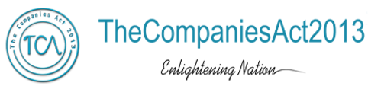
ANNEXURE X
Form A (for audit report with unmodified opinion) or
Form B (for audit report with modified opinion) along-with Financial Results
FORM A (for audit report with unmodified opinion)
 | Name of the company | XYZ Ltd.
 | Annual financial statements for the year ended | 31st March ……..
 | Type of Audit observation | Un Modified / Emphasis of Matter
 | Frequency of observation | Whether appeared first time……/ repetitive……./ since how long period…….
To be signed by-
- CEO/Managing Director
- CFO
- Auditor of the company
- Audit Committee Chairman

FORM B (for audit report with modified opinion)

 | Name of the company | XYZ Ltd.
 | Annual financial statements for the year ended | 31st March ……..
 | Type of Audit qualification | Qualified/Disclaimer of Opinion/Adverse
 | Frequency of qualification | Whether appeared first time……/  repetitive……./ since how long period …….
 | Draw attention to relevant notes in the annual financial statements and management response to the qualification in the directors report: | May give gist of qualifications/headings (Refer page numbers in the annual report) and management’s response
 | Additional comments from the board/audit committee chair: | This may relate to nature of the qualification including materiality, agreement/disagreement on the qualification, steps taken to resolve the qualification, etc.
To be signed by-
- CEO/Managing Director
- CFO
- Auditor of the company
- Audit Committee Chairman

